
Obstetrics and Gynaecology

egkjk"V! inO;qRrj oS|dh; f'k{k.k o la'kks/ku laLFkk evkfofo] ukf'kd
MAHARASHTRA POST GRADUATE INSTITUTE OF EDUCATION & RESEARCH M.U.H.S., NASHIK
ftYgk jQX.kky; vkokj] _;acd jksM] ukf'kd&422002
Civil Hospital Campus, Trambak Road, Nashik-422002.

Date - / /2026.

PROGRAM REPORT
Title of the program – Aamdar Ajitdada Pawar Jayanti Cancer Awareness Campaign Organising Department -
Department of Obstetrics and Gynaecology, MPGIMER, MUHS, Nashik
Date and Time 26/07/26 to 28/7/26 9am to 5pm
Venue: OPD 31 and PNC Ward Civil Hospital, Nashik Program Incharge : Dr. Prasannajeet Kokate Program Organised by : Dr.Darshana Shelar Supporting staff members : Dr.Aashna Agarawal
Dr. Bhagyashree Wagaskar Dr. Jyoti Meena
Vote of thanks presented by : Dr Darshana Shelar
Number of Participants in Pap Smear Screening Program – 100

Objectives of the program

- To increase awareness about cervical cancer and its prevention.
- To educate women about the importance of regular Pap smear screening.
- To promote early detection of precancerous and cancerous cervical lesions.
- To encourage eligible women to undergo Pap smear testing regularly and make them aware of HPV vaccination.

Brief about program
An extensive programme spanning over 3 days was organized by the Department of Obstetrics and Gynaecology, MPGIMER, Nashik, to educate women about cervical cancer prevention and the importance of regular Pap smear screening. The itinerary include :

Day 1, 26/7/26 12 noon Location: PNC ward, Civil hospital
Street Play on Topic - Silent Killer Virudh Jeevanacha Kawach – A Awareness Skit on Cervical Cancer and HPV vaccine
conducted by Residents – Dr.Priyanka Pandya, Dr.Komal Podhade, Dr.Priyanka Singh & Interns – Dr.Rutuja, Dr.Pradip, Dr.Abhishek, Dr.Priyanka Patil.
Educational Slide Presentation by Senior Resident Dr. Bhagyashree Wagaskar on risk factors, early warning signs, symptoms , paper smear screening procedure, site & prognosis of Cervical Cancer, benefits of early detection and HPV Vaccination to encourage all patients & their relatives visiting OPD & admitted in PNC, Gynaecology Ward, FSW, FOW & FMW for timely rountine Pap Smear screening.

Day 2, 27/7/26 Location : GYnae OPD Civil hospital
PAP SMEAR Screening Program - A pap smear screening camp was organized in Opd 31.
Conducted by the whole department of Obstetrics and Gynaecology. A significant number of female relatives and patients admitted in the Civil hospital showed up for the screening program. Pap smears were taken from PNC, Gynaecology Ward, FSW, FOW & FMW and sent to HLL lab for testing.
Number of patients screened by Pap Smear Testing – 64

Day 3 , 28/7/26 OPD Porch civil hospital
A Street Play on Topic - Silent Killer Virudh Jeevanacha Kawach – A Awareness Skit on Cervical Cancer

Another session of street play regarding awareness on Cervical cancer and HPV vaccine was conducted in Main Opd area for the outdoor patients of all departments.
conducted by Residents – Dr.Priyanka Pandya, Dr.Komal Podhade, Dr.Priyanka Singh & Interns – Dr.Rutuja, Dr.Pradip, Dr.Abhishek, Dr.Priyanka Patil.

The play gracefully expressed the risk factors, symptoms and screening modalities in Marathi, the vernacular, for the ease of patients.200patients participated as spectators.

HOD & Professor Department of OBGY

MPGIMER, MUHS Nashik.

Obstetrics and Gynaecology
egkjk"V! inO;qRrj oS|dh; f'k{k.k o la'kks/ku laLFkk evkfofo] ukf'kd
MAHARASHTRA POST GRADUATE INSTITUTE OF EDUCATION & RESEARCH M.U.H.S., NASHIK
ftYgk jQX.kky; vkokj] _;acd jksM] ukf'kd&422002
Civil Hospital Campus, Trambak Road, Nashik-422002.

Date - / /2026.

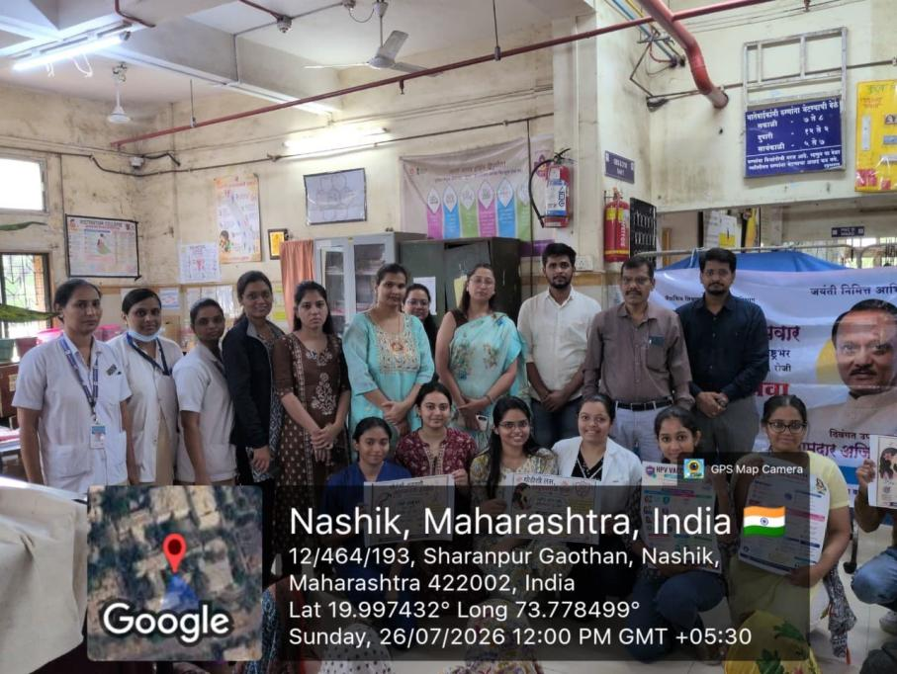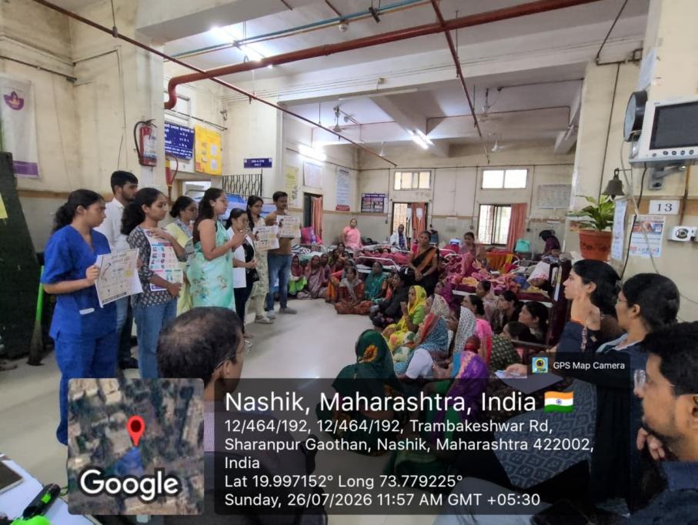

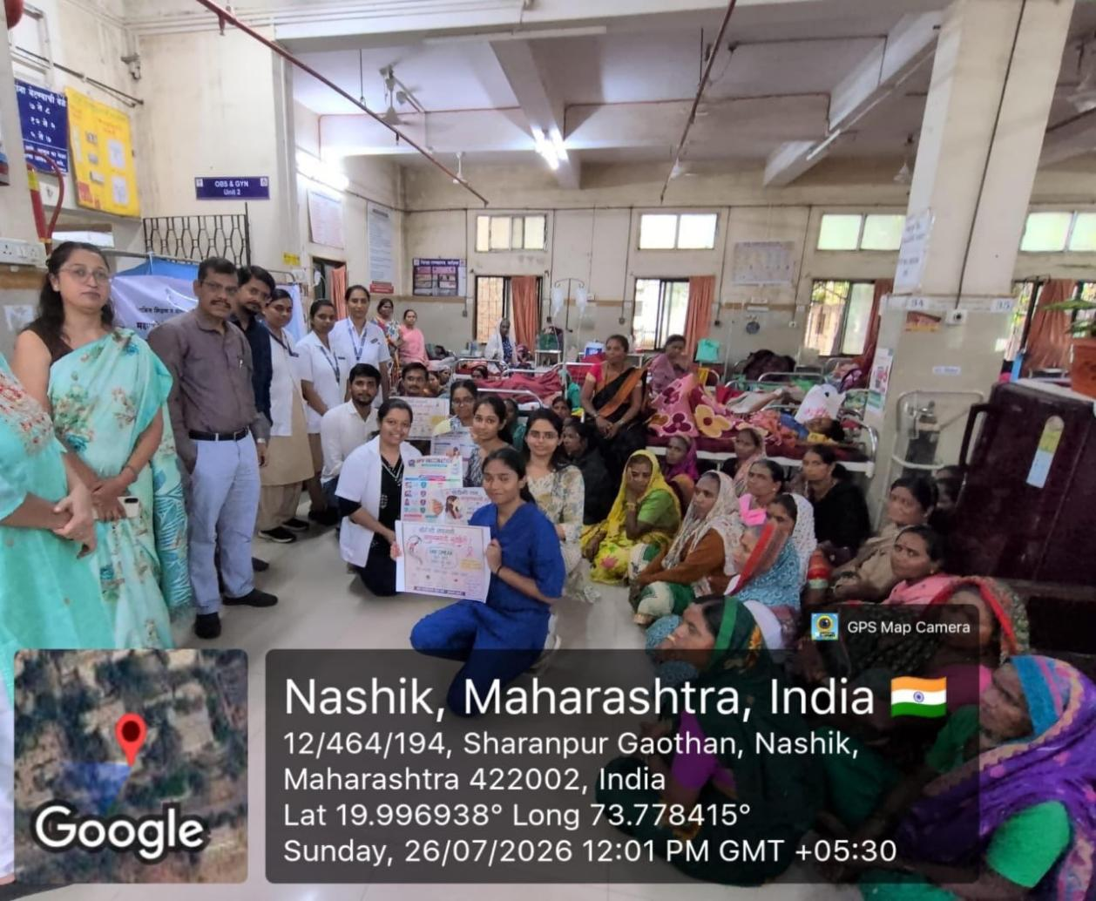

Obstetrics and Gynaecology
egkjk"V! inO;qRrj oS|dh; f'k{k.k o la'kks/ku laLFkk evkfofo] ukf'kd
MAHARASHTRA POST GRADUATE INSTITUTE OF EDUCATION & RESEARCH M.U.H.S., NASHIK
ftYgk jQX.kky; vkokj] _;acd jksM] ukf'kd&422002
Civil Hospital Campus, Trambak Road, Nashik-422002.

Date - / /2026.

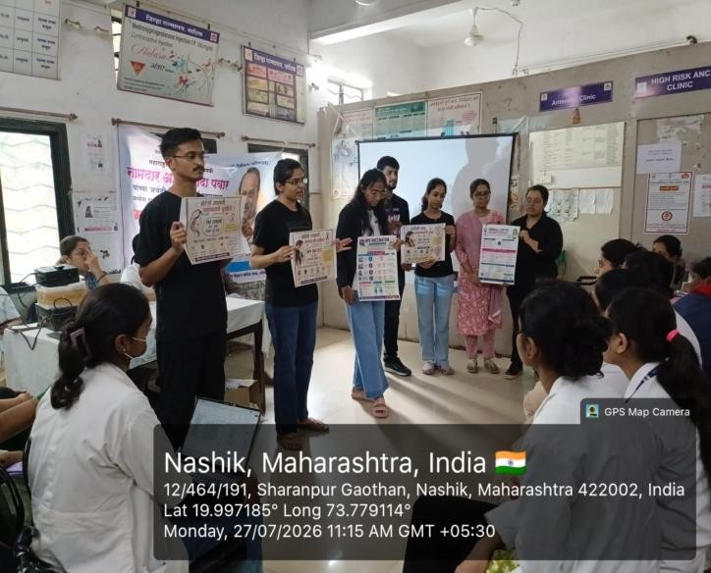
Insight into day 2

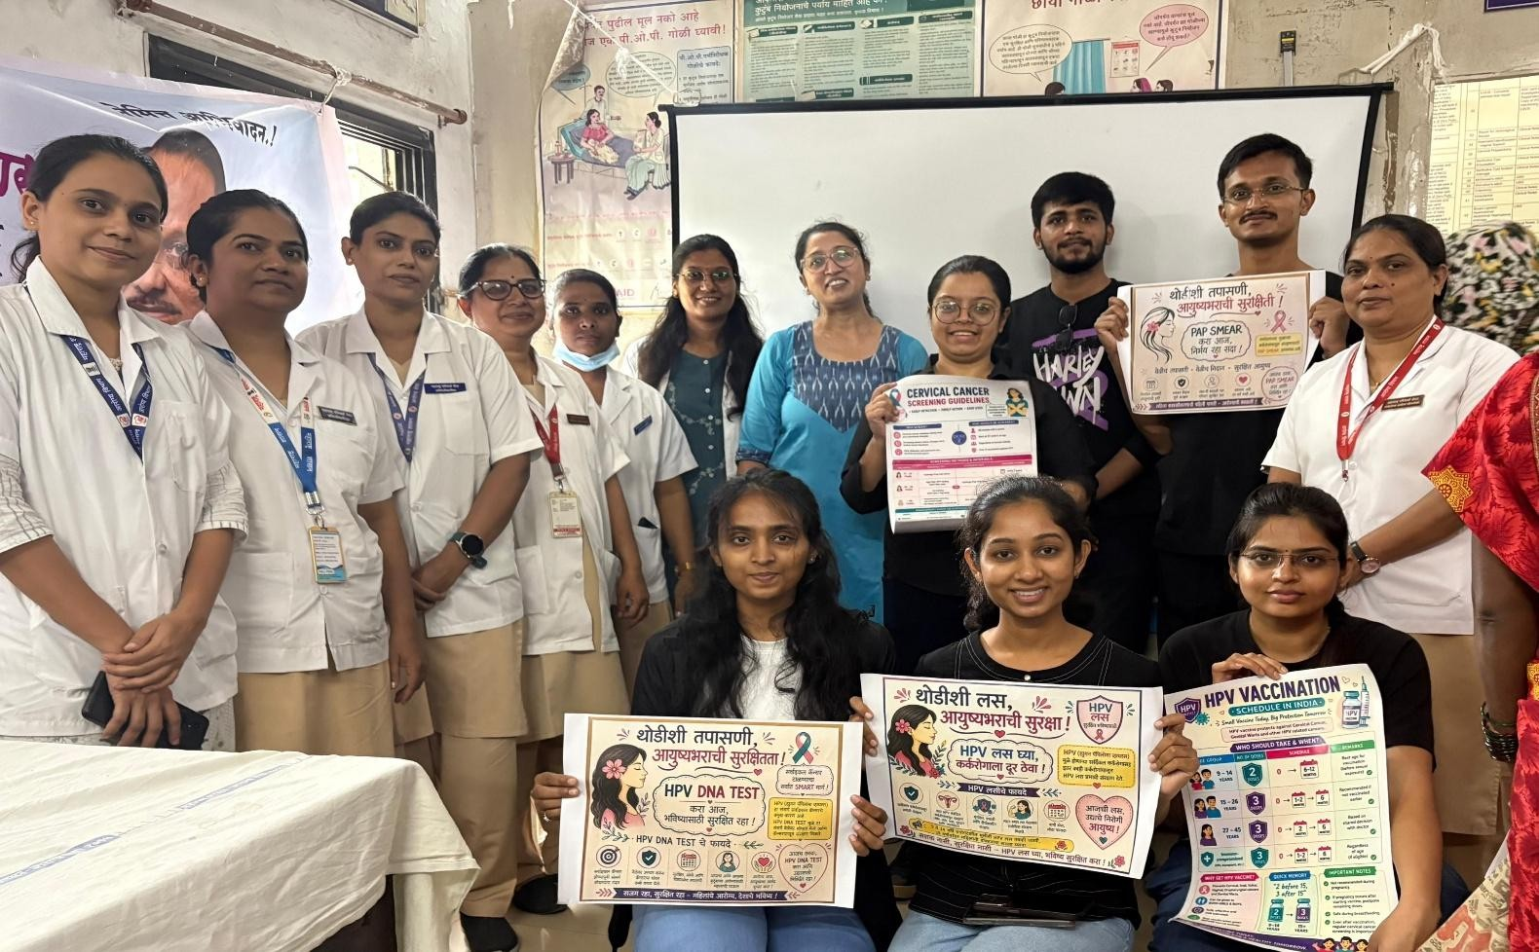

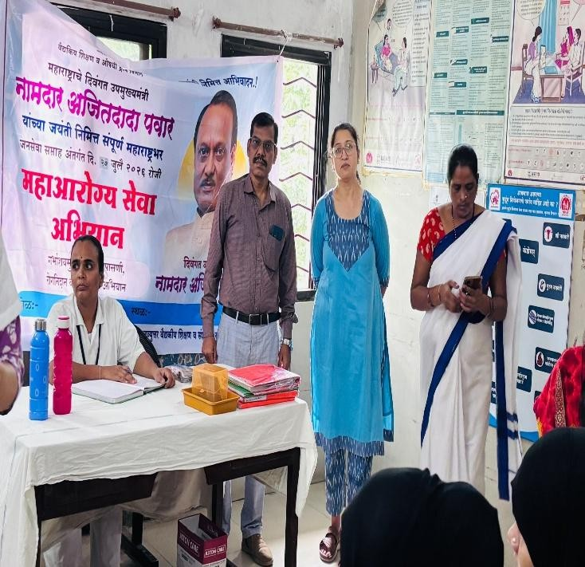

HOD & Professor

Department of OBGY

Obstetrics and Gynaecology
egkjk"V! inO;qRrj oS|dh; f'k{k.k o la'kks/ku laLFkk evkfofo] ukf'kd
MAHARASHTRA POST GRADUATE INSTITUTE OF EDUCATION & RESEARCH M.U.H.S., NASHIK
ftYgk jQX.kky; vkokj] _;acd jksM] ukf'kd&422002
Civil Hospital Campus, Trambak Road, Nashik-422002.

Date - / /2026.

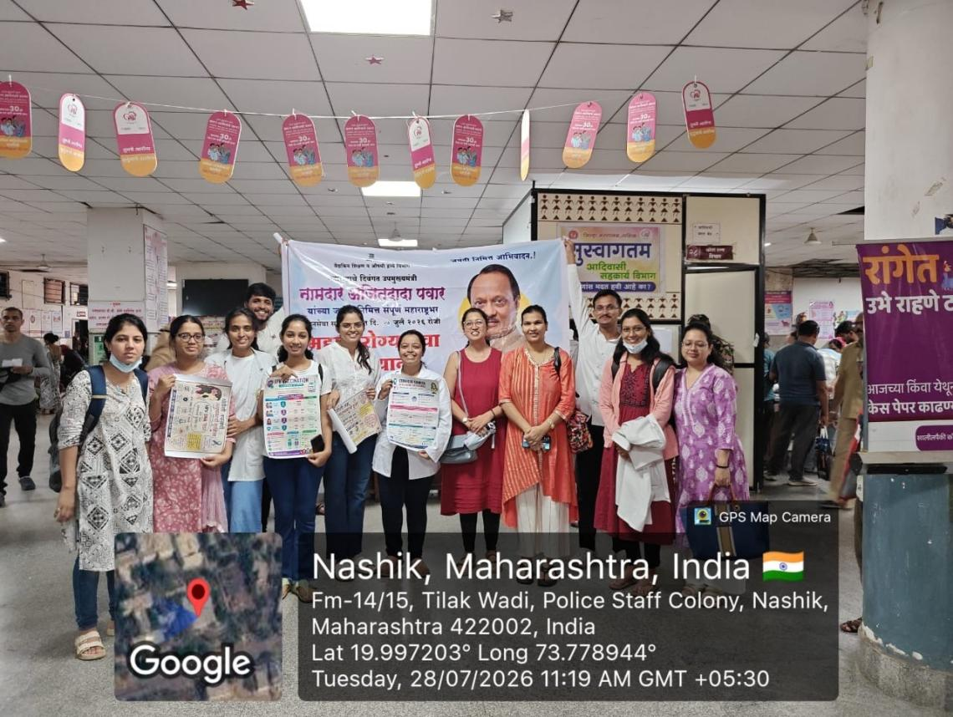
Insight into day 3

